**Marks: /31**



|  |  |
| --- | --- |
| Student Name |  |

**Time allowed for this paper**

Reading time before commencing work: 2 minutes

Working time for paper: 30 minutes

**To be provided by the supervisor:**

This Question/answer booklet;

Formulae and constants sheet

**To be provided by the candidate**

Standard items: Pens, pencils, eraser or correction fluid, ruler, highlighter

Special items: Drawing instruments or templates.

A **scientific** (i.e. non graphics) calculator satisfying curriculum council requirements.

**Instructions to candidates**

1. To achieve full marks, clear, logical working and diagrams MUST be shown.
2. When calculating numerical answers, show your working or reasoning clearly. Give final answers to **three** significant figures and include appropriate units where applicable. Estimates should be to two significant figures.

**Question 1**

Three students are using a piece of string to make a standing wave. The following graph shows the wavelength of part of the string at one particular instance.

Examine the graph and determine the waves:

Amplitude ______________________________

Wavelength ____________________________ **(2 marks)**

**Question 2**

If the wave in the graph for question (1) is travelling at 4.00 ms-1, what is the period of the wave?

**(3 marks)**

**Question 3**

Determine the amplitude and period of the wave as shown by the graph below:

**(2 marks)**

**Question 2**

If the wave in question 3 is travelling at 15ms-1, what is the wavelength of the wave?

**(2 marks)**

**Question 3**

A sound wave has a frequency of 2.00 kHz, and the distance between two crests is 0.175m. How long will the wave take to reach an observer who is 200m away?

**(3 marks)**

**Question 4**

Compare and contrast the motion of longitudinal and transverse waves, including their motion in a ‘medium’.

__________________________________________________________________________________________________________________________________________________________________________________________________________________________________________________________________________________________________________________________________________________________________________________________________________________________________________________________________________________________________________________________________________________________________

**(3 marks)**

**Question 5**

A signal generator sends out a frequency of 1500 Hz on a day when the speed of sound was measured to be 351.5 ms-1 . **(6 marks)**

1. What is the time period of the wave?

(2 marks)

1. What is the wavelength of the wave?

(2 marks)

1. What will be the effect on the wave’s frequency and wavelength as it passes into a body of water where the speed of sound is 1450 m.s-1?

________________________________________________________________________________________________________________________________________________________________________________________________________________________________________________________________________________________________________________________

(2 marks)

**Question 6**

For the following displacement-distance graph, first label the axes and then identify the following characteristics:

* Amplitude
* Crest
* Trough
* Amplitude

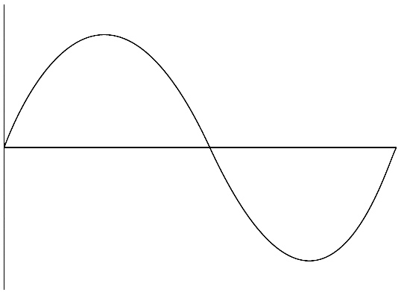

Show how you would calculate the frequency if you knew the period:

(4 marks)

**Question 7**

For the following displacement-distance graph, first label the axes and then identify the following characteristics:

* Wavelength
* Amplitude
* Crest
* Trough



(3 marks)

**Question 8**

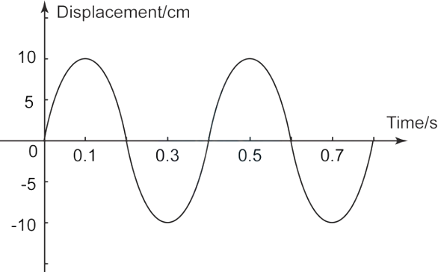

1. Use the graph to determine the amplitude of the waves.
2. Use the graph to determine the period of the waves.
3. Calculate the frequency of the waves.

(3 marks)